

Shandong Time Machinery Technology Co., Ltd.

"PC Rebar Truss Welding Production Line (SGHJ-IV)"
Equipment Information

Legal representative: Cui Hao
Phone: 13395378282
Address: Economic Development Zone, Jining City, Shandong Province
Website: www.sdsgzn.com

· High Energy Efficiency
· Continuous Improvement

· Mutual Benefit
· Trustworthy Cooperation



Table of Contents
I. Introduction to PC Composite Slab Project 3
1. Project Overview 3
2 .Production Process Introduction 4
3.PC Rebar Truss Finished Product (Right Angle Truss) 5
II.Equipment Performance and Technical Parameters 6
1.Technical Parameters of Rebar Truss Production Line 6
1.1 Equipment Overview 6
1.2 Equipment Composition of Rebar Truss Production Line 6
1.3 Equipment Technical Parameters： 7
1.4 Equipment Features 8
1.5 Equipment Configuration and Component Brands 10
2. Cooling water machine 11
2.1 Technical Specifications of Air-Cooled Box Cooling Unit： 11
3. Air Compressor 12
1.Technical Parameters of Screw Air Compressor 13



Business quotation
Intelligent CNC Truss Welding Production Line Professional Manufacturer
SGHJ-IV Intelligent CNC Truss Welding Production Line Quotation
Quotation unit: Shandong Shiguang Machinery Technology Co., Ltd.
Serial  No. | Equipment name |  | Equipment model |  | Units |  | Quantity | Cost price  (USD) | Amount  (USD)
1 |  | Square Pipe Rebar Truss Welding Production Line |  | SGHJ-IV | Unit | 1 |  | 150000 | 150000
2 |  | Screw air compressor |  | KAIZEN BK series 37kw | Unit | 1 |  | 11000 | 11000
3 |  | Cooling water machine |  | RX-10A | Unit | 1 |  | 7000 | 7000
4 |  | Rebar Welding Machine |  | 25kva | Unit | 1 |  | 2000 | 2000
Total |  | USD: $170000
Note: This price includes tax.
Our company focuses on the research and development and manufacture of steel truss welding production line, with specialized and efficient technology research and development team, the company attaches importance to technological innovation, insists on taking the road of independent innovation, constantly adjusts the product structure to meet the market demand, and establishes long-term cooperative partnership with a number of well-known enterprises.

2. Payment method, payment period, and ownership of property rights:
1.Pay 30% of the total contract price as deposit within three days after the contract is signed;
2.Payment for shipment: 70% of the total contract price before shipment of contract goods;

▶ Remittance Information
Company name: Shandong Time Machinery Technology Co. Ltd
Tax identification number: 91370811MA3EP7HT68
Account number: 815010601421010400
Bank: Jining Bank Xicheng Sub-branch
Address: Jining Economic Development Zone, Shandong Province, east of Jiafeng Road, north of Ruixiang Road (Shandong Taifeng Engineering Group Co., Ltd. yard) Tel: 13954713947

I.Introduction to PC Composite Slab Project
1. Introduction to PC Composite Slab Project
1. Project Overview
Composite floor slab is a structural form that combines prefabricated and cast-in-place concrete. The prestressed thin plate (5-8 cm thick) is integrated with the upper cast-in-place concrete layer to form a unified structure and work together. The prestressed main reinforcement of the thin plate serves as the main reinforcement of the composite floor slab, while the upper cast-in-place layer only requires negative moment reinforcement and structural reinforcement. The prestressed thin plate also serves as the bottom formwork for the cast-in-place concrete layer, eliminating the need for additional formwork support. The bottom surface of the thin plate is smooth and even, and after joint treatment, there is no need for plastering the ceiling. These composite floor slabs have the advantages of overall integrity, high rigidity, good crack resistance, no increase in steel consumption, and savings in formwork. Additionally, the absence of formwork support for the cast-in-place floor slab allows for the early installation of large prefabricated concrete partition walls, thereby shortening the overall construction period.

Application Range and Classification
These floor slabs are suitable for buildings with spans up to 8 meters, including hotels, office buildings, schools, residential buildings, hospitals, warehouses, parking lots, and multi-story industrial plants. Depending on the structure of the composite surface, prestressed thin plates can be categorized into three types: ① For composite surfaces that bear low shear stress, no shear reinforcement is required, but the concrete surface should be rough, scratched, or include some bonding holes. ② For composite surfaces that bear high shear stress, in addition to requiring a rough surface, shear reinforcement should be added. The diameter and spacing of the reinforcement are determined through calculations, and reinforcement shapes include waveform, helical, and spot-welded mesh with bent triangular cross-sections. ③ For prefabricated thin plates, a steel truss is added to the upper surface to enhance stiffness during construction and reduce the need for supports under the thin plates.

·High Energy Efficiency
·Continuous Improvement

· Mutual Benefit
·Trustworthy Cooperation

2


山东时 光 机 械科技有限公司
SHANDONG TIME MACHINERY TECHNOLOGY CO., LTD.

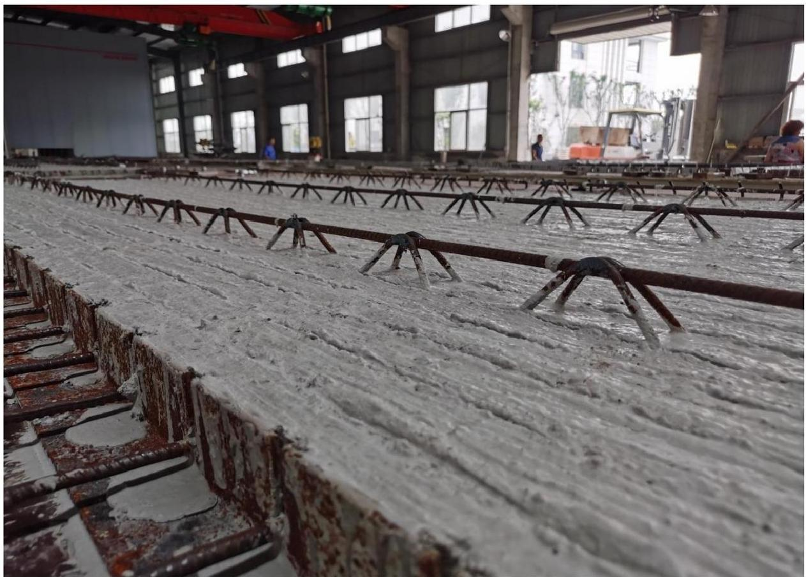

2. Production Process Introduction

·High Energy Efficiency
·Continuous Improvement

· Mutual Benefit
·Trustworthy Cooperation

3



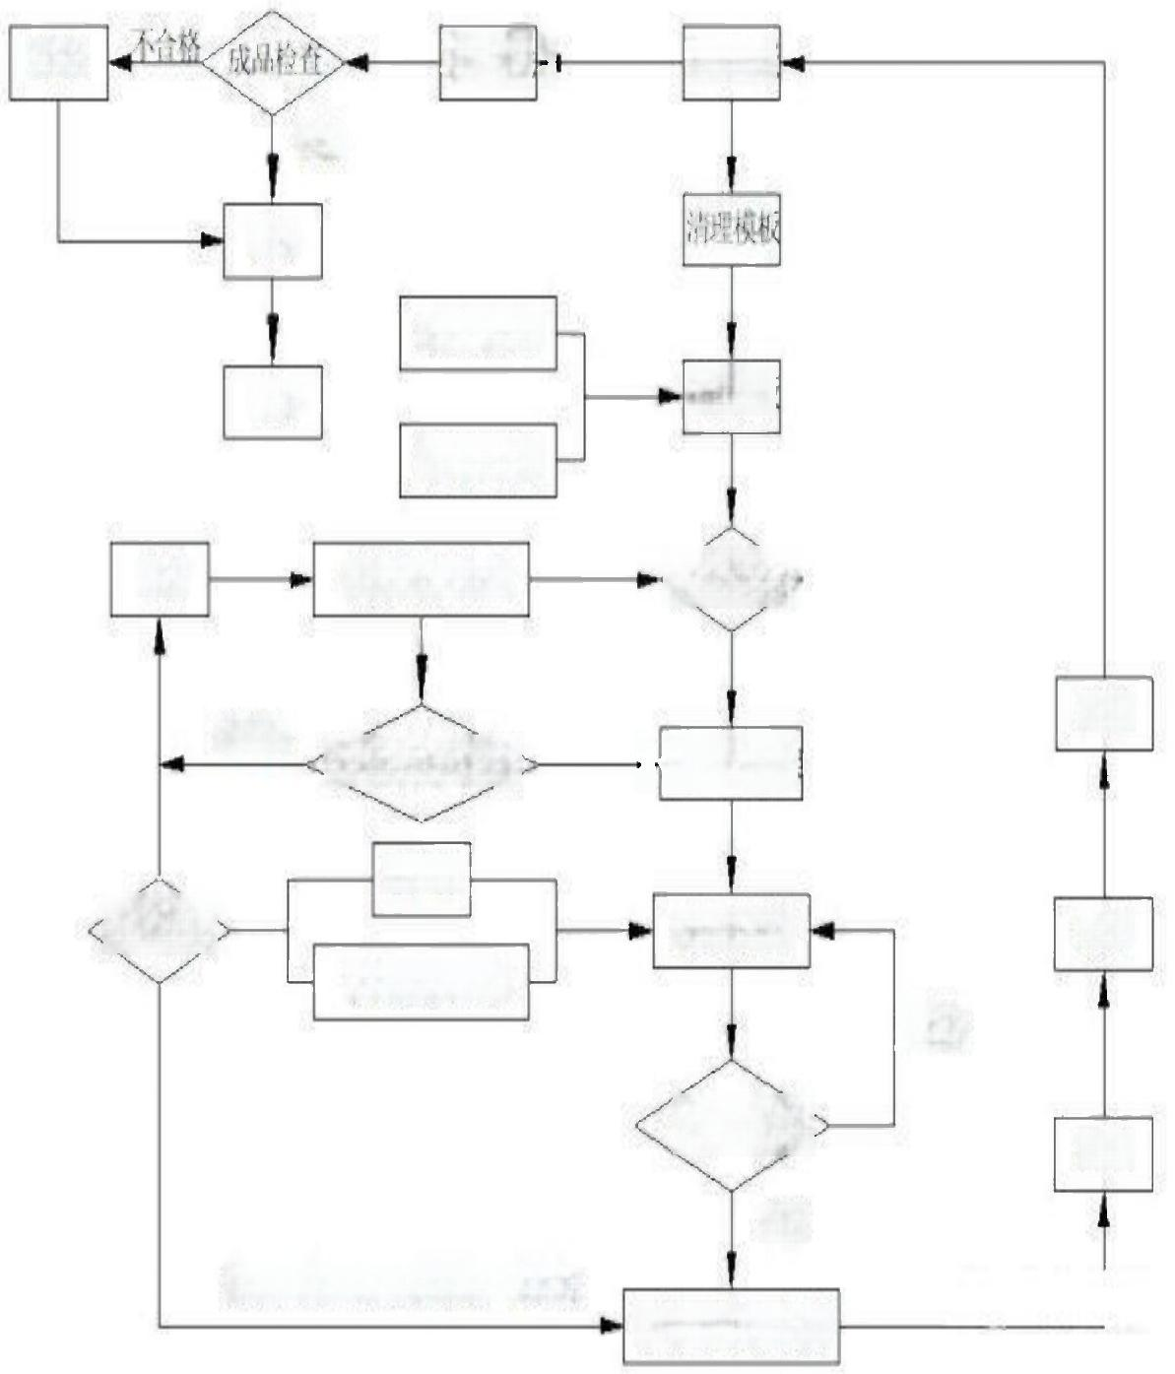
Inspection prior to Pouring

Template Cleaning

Unqualified
Finished Product Inspection

Demoulding
and
Cleaning

Qualified

Annotation

Application
of Setting
Retarder
Inventory

Application of
Demoulding
Agent

Grooving Rebar Semi-finished
Product Processing

Steam
Curing

Rebar Backbone
Binding

Embedded
Components
Raw
Materials

Reserved Holes
and Lifting Points

Unqualified

Qualified

Cement, Sand, Aggregate, Fly Ash, Admixtures
Concrete Pouring
and Compaction

Template
Assembly

Rebar Semi-finished
Product Inspection

Installation of Embedded Components

Template Assembly

Template Removal

Unqualified
Troweling

Repair

Pre-curing

3. Rebar Truss Finished Product (Right Angle)

·High Energy Efficiency
·Continuous Improvement

· Mutual Benefit
·Trustworthy Cooperation

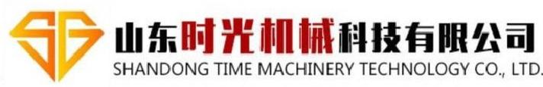

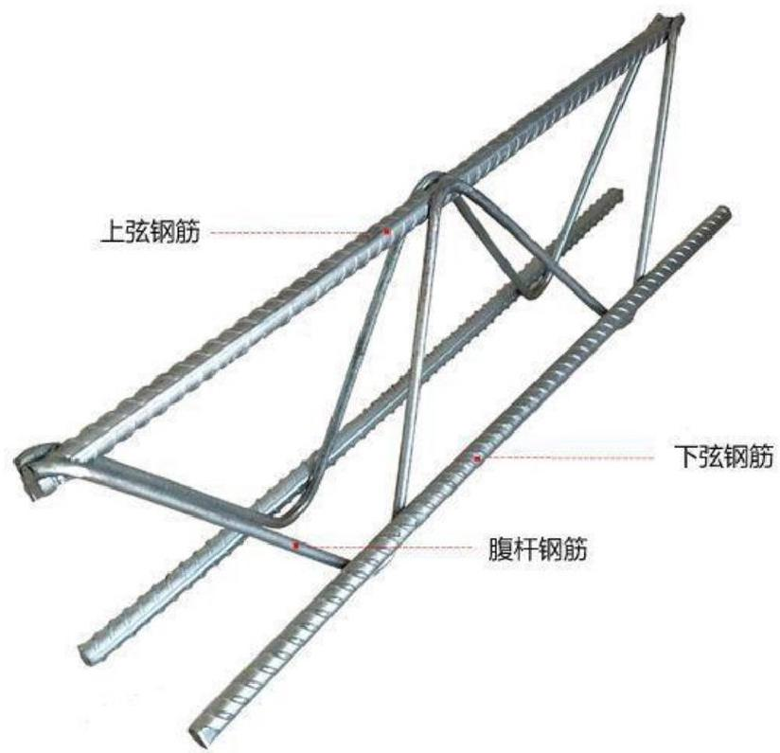
Diagonal Member Reinforcement

Lower Chord Reinforcement

Upper Chord Reinforcement

II. Equipment Performance and Technical Parameters

·High Energy Efficiency
·Continuous Improvement

· Mutual Benefit
·Trustworthy Cooperation



山 东时光
SHANDONG TIME

机 械科技有限公司
MACHINERY TECHNOLOGY CO., LTD.

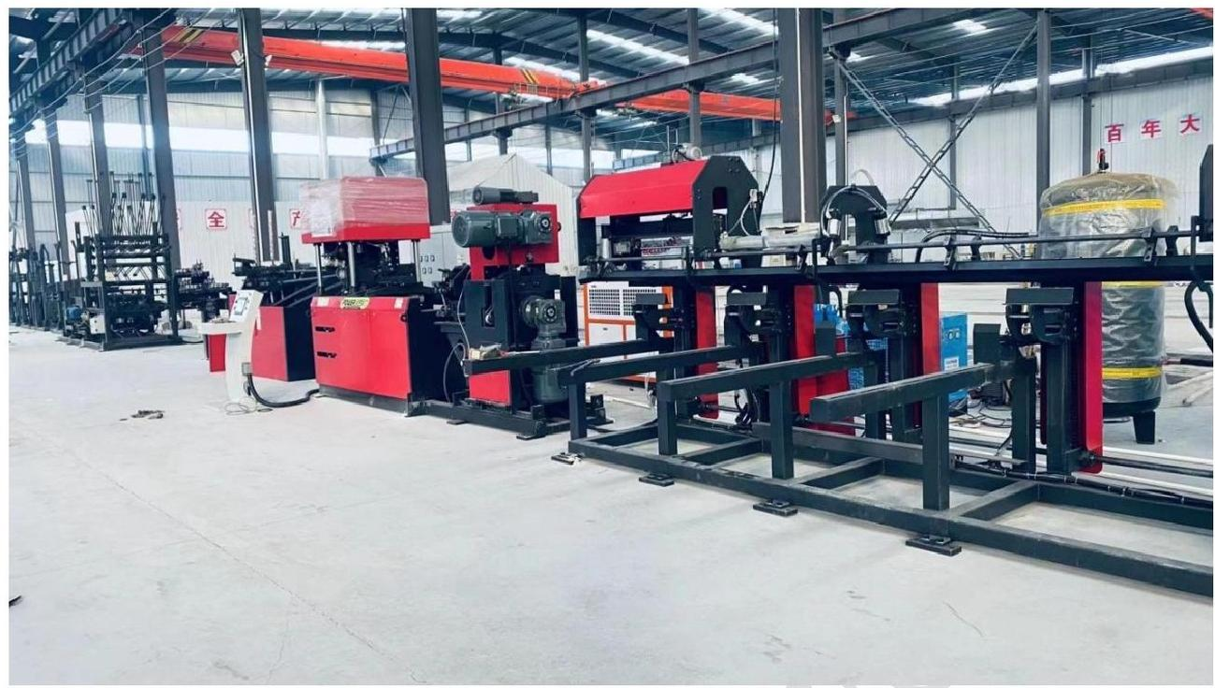

1.Technical Parameters of Rebar Truss Production Line
1.1 Equipment Overview
The rebar truss production line is a fully automated production line that integrates rebar coil wire laying, straightening, side steel bending, welding forming, automatic cutting, and finished product collection. It can produce rebar trusses for floor slabs as well as prefabricated building PC rebar trusses, widely applied in building construction (prefabricated floor slabs) and high-speed railway construction (double-block sleepers), among other fields.

1.2 Equipment Composition of Rebar Truss Production Line:

No. | Equipment Components | Quantity | Technical Features
1 | Coil Rebar Wire Laying Rack | One set | Vertical Wire Laying Rack
2 | Straightening and Feeding Mechanism | One set | Adopts Multi-Wheel Straightening with excellent straightening effect without damaging rebar ribs; Dual-driven wire feeding with three deceleration motors.
3 | Material Storage Mechanism | One set | Equipped with a new type of open storage rack that utilizes cushioning storage, allowing for continuous production and preventing rebar accumulation effectively.
4 | Terminal Straightening Mechanism | One set | Second-stage terminal straightening is conducted on the main reinforcement and diagonal members before welding and forming using a five-roller straightening method, ensuring the straightness of the truss products.

·High Energy Efficiency
·Continuous Improvement

· Mutual Benefit
·Trustworthy Cooperation

6



5 | Diagonal Member Bending Mechanism | One set | 1) Pendulum rod bending is powered by a servo motor, ensuring good synchronization and high stability.  2) Wire feeding mechanism is powered by another servo motor, offering better synchronization and higher accuracy. When combined with the bending mechanism, the perfect cooperation of the two servo motors enables changing of truss pitch without stopping the machine, significantly enhancing production efficiency.
6 | Welding Main Unit | One set | Two spot welds are used, employing a total of 2 transformers, which reduces the total power consumption of the welding transformers by over 60 percent.
7 | Cutting Mechanism | One set | Utilizes a "scissor-type" cutting mode to effectively solve the problem of open welds caused by the cutting process. This mode also helps avoid truss skewing and distortion during the cutting process. The cutting position adjustment is controlled by servo motor, enabling cutting of trusses of any length without stopping the machine.
8 | Aggregate Collection Mechanism | One set | Automatic stacking
9 | Electrical Control System | One set
10 | Operating System | One set | Operating buttons and other components are of high-quality  Convenient equipment operation and adjustment  Convenient operation of speed, welding parameters, etc.  Truss reservation system
11 | Instruction Manual, Spare Parts, and Tools | One set | Standard configuration

1.3 Equipment Technical Parameters:

Swing Arm | Unit | Quantity | Note
Load Capacity of Wire Laying Rack | kg | 2000 | The height of the upper chord should not exceed 2 meters, and the height of the lateral chord should not exceed 1.3 meters.
Number of Wire Laying Racks | Units | 5
Power of Side Steel Forming Motor | Kw | 7.5
Power of Welding Transformer | KVA | 160x2 | Intermittent operation

·High Energy Efficiency
·Continuous Improvement

· Mutual Benefit
·Trustworthy Cooperation

7



Shear motor power | Kw | 11+11 | Intermittent operation
Collecting and lifting rack motor power | kw | 2.2 | Intermittent operation
Lateral chord bending pitch | mm | 200 | 190-210 automatically adjustable pitch
Chord height | mm | 70-270 | Height of 250 and above without bottom angle chord
Chord width | mm | 70-90 | Large width
Diameter of upper and lower chord bars | mm | 6-12
Diameter of lateral chords | mm | 4-7
Length of the chord | m | 0.2~14 | Automatic adjustable pitch
Straightness of the chord | mm | ±5
Height error of the chord | mm | ±2
Length error of the chord | mm/m | ±5 | Maximum error not exceeding ±15mm
Height of the exposed upper and lower chord bars | mm | ≤5
Speed of the production line | m | 12-15 | The actual stable production speed is determined by the specifications of the chord.
Air pressure | Mpa | ≥0.7 | The gas used should be clean, filtered and dried.
Air consumption | m³/min | 3/4.5
Length of the production line (length * width * height) | mm | The length of the production line can be adjusted appropriately to 45000*3000*3500.
Total production | T | ≤18 (excluding accessories and external control boxes)
Note: Standard configuration includes bottom angle bending mechanism. Please specify if the configuration for residential industrialization does not include the bottom angle bending mechanism.

1.4 Equipment Features

1. Rubar laying frame
There are five sets of bar payoff stands, using rotating payoff method, with a maximum load of 2 tons.
Each payoff stand is equipped with independent air braking device.
Each payoff stand has an independent pre-straightening mechanism to remove the oxide scale on the surface of the steel bars.
·High Energy Efficiency · Mutual Benefit
·Continuous Improvement ·Trustworthy Cooperation



2. Straightening and Feeding Mechanism
It uses multi-wheel straightening with good straightening effect, without damaging the ribs of the steel bars. Three deceleration motors are used for feeding.
Each feeding mechanism can be controlled independently.
3. Steel Bar Storage Mechanism
It adopts a new type of open storage rack for buffering and storage, which is convenient for continuous production and effectively prevents steel bars from tangling.
4. Terminal Straightening Mechanism
Secondary terminal straightening is performed on the main bar and the web bars before welding and forming. Five-roll straightening is used to ensure the straightness of the finished truss.
This mechanism plays a key role in adjusting the straightness of the truss products.
5. Web Bar Pressing and Feeding Mechanism
Swing-arm bending is used for bending the steel bars, powered by a servo motor, with good synchronization and high stability. Steel bar bending is continuous (the bending mechanism works in a circular and up-and-down swinging motion, without delay), with fast forming speed. The steel bar forming molds have cylindrical surfaces to prevent scratching the surface of the steel bars. The feeding mechanism is powered by a servo motor, with better synchronization and accuracy. With the coordination of the bending mechanism, the perfect combination of the two servo motors can realize the function of changing the truss pitch without stopping, greatly improving the production efficiency.
6. Welding Part
Two spot welders, one on the top and one on the bottom, with two transformers in total. Four lower press rollers with good synchronization.
The welding cylinders have a small stroke, large force, fast welding speed, and high quality.
The welding cylinders use high-quality brands and are air clamped.
The welding electrodes are made of chrome-zirconium alloy copper.
Equipped with positioning mechanism to ensure the shape and size of the welding.
The two-point resistance spot welding method reduces the installation power by 60% compared to peers, and the welding parameters of each welding point can be set independently.
The four-way electrode head can be reused four times, reducing the cost by 3 times.
7. Cutting Mechanism
The "scissor-type" cuttingmode is adopted to effectively solve the problem of open weld caused by cutting process and avoid deformation and distortion of the truss during cutting.
Fast cutting speed, no need to stop welding.
For high-strength cutting at the main and side reinforcement welding joints, the latest developed high-strength and tough mold steel from China is used.
8. Automatic Collection and Stacking Mechanism
The automatic collection mechanism allows continuous production without the need to stop, improving efficiency.
It can collect trusses of different sizes, long and short.
The automatic collection, stacking, and shipping of trusses are all fully automated.
The automated collection and stacking device reduces the number of operators by 2.
9. Electrical Control System
It adopts the control system from Hechuan with high stability.
10. Operating System
Operating buttons and other components use high-quality products.
The equipment is easy to operate and adjust.
Operations such as speed, welding parameters, etc. are convenient.

· High Energy Efficiency
· Continuous Improvement

· Mutual Benefit
· Trustworthy Cooperation



1.5 Equipment Configuration and Component Brands

Name | Brand | Explanation  Remarks
Operating Screen | Kunlun Tongtai | It is an intelligent IoT touch screen with ARM CPU as the core and 800MHz main frequency. The product design adopts 10-inch TFT LCD, resolution 1024 * 600, four-wire resistive touch screen, and also pre-installed with McsgPro configuration software.
PLC | Hechuan | High performance, compact structure, powerful functions, and high stability.
Servo Motor | Hechuan | High performance, high reliability, and high quality.
Low Voltage Control | CHNT | Chinese well-known brand, stable quality, high reliability.
Switching Power Supply | Taiwan Mingwei | Taiwan well-known brand with over 30 years of research and manufacturing experience.
Welding Transformer | Chengtai | Using Japanese welding technology.
Air Components | Yadeke | Taiwan well-known brand, good quality, high reliability, high load capacity.
Solenoid Valve | Yadeke
Welding Cylinder | Shuangbeili Custom Cylinder | Fast speed, sufficient power, and high stability.
Welding Controller | Shanghai Guolong | Stable product performance and reliable quality.
Reducer | Zhejiang Tianhong | Stable and reliable performance.
Linear Guide Rail | Taiwan Shangyin | High load capacity, high precision, high speed, and high accuracy.
Bearing | Nsk | Imported quality, stable quality, and high reliability.
Electric Wire, Cable | Guangdong Yingke | Excellent material, strong insulation, low eccentricity.

·High Energy Efficiency
·Continuous Improvement

· Mutual Benefit
·Trustworthy Cooperation

10



2. Cooling water machine

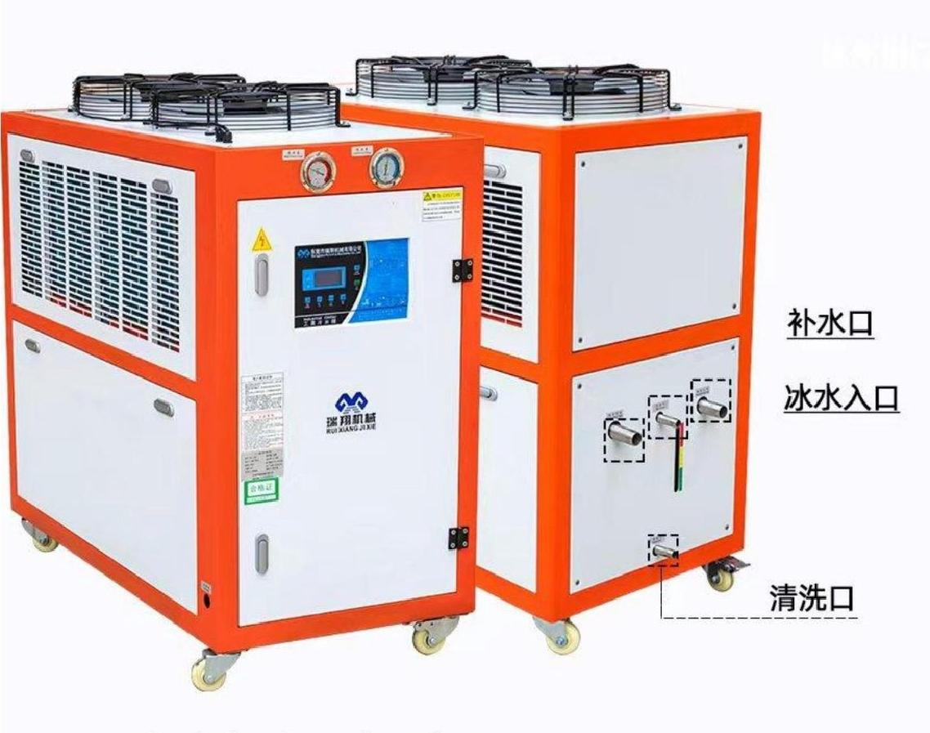
Cleaning port.

Water refill port

Ice water inlet.

Cooling water machine length * width * height = 1310 * 630 * 1230mm.

Technical specifications of air-cooled box type chiller unit are as follows：

Model  Items |  | RX-05A | Configuration
Power Supply |  | 380V/3PH/50HZ
Cooling Capacity | Kcal/h | 12900
Cooling Capacity | kw | 15
Total Input Power | kw | 4.48
Coolant | Name | R22 | Imported high-quality coolant.
Coolant | Control Method | Capillary tube | Imported high-quality coolant.

·High Energy Efficiency
·Continuous Improvement

· Mutual Benefit
·Trustworthy Cooperation

11



Compressor(Veneer Press) | Type | Scroll type | Carlyle(USA )
Compressor(Veneer Press) | Power (kw) | 3.75 | Carlyle(USA )
Compressor(Veneer Press) | Number of Stages | 5 | Carlyle(USA )
Fan | Power (kw) | 0.18*2 | Low-noise fan
Fan | Air Volume (m³/h) | 7840 | Low-noise fan
Coolant | Type | Air-cooled fin efficient heat exchanger | Air-cooled fin efficient heat exchanger
Coolant | Cooling Air Volume (m³/h) | 5000 | Air-cooled fin efficient heat exchanger
Evaporator | Type | Water tank coil (stainless steel) | Water tank coil (stainless steel)
Evaporator | Chilled Water Flow (m³/h) | 2.5 | Water tank coil (stainless steel)
Evaporator | Water Tank Capacity (L) | 60 | Water tank coil (stainless steel)
Evaporator | Inlet and Outlet Pipe Diameter | 1" | Water tank coil (stainless steel)
Water Pump | Power (kw) | 0.37 | Aoyuan
Water Pump | Head (m) | 20 | Aoyuan
Water Pump | Flow Rate (m³/h) | 6 | Aoyuan
Safety Protection | Panel | Compressor overheating protection, overload protection, high and low pressure protection, over temperature protection, flow protection, phase sequence/phase missing protection, exhaust overheating protection, automatic prompting system for inadequate cooling water. | Punp computer
Safety Protection | High and low pressure gauge |  | Taiwan JAVE
Safety Protection | Filter |  | ALCO (USA)
Safety Protection | Phase sequence relay |  | Schneider (France)
Safety Protection | Contactor |  | Schneider (France)
Safety Protection | Main switch |  | Schneider (France)
Machine Description | Weight (kg) | 174.5 | Wooden frame packaging
Machine Description | Dimensions (mm) | 1310*630*1230
Machine Description | Surface Treatment | 2mm main board, 1.5mm sealed board. | Electrostatic spray.

3. Air Compressor

·High Energy Efficiency
·Continuous Improvement

· Mutual Benefit
·Trustworthy Cooperation

12


山东时 光 机 械科技有限公司
SHANDONG TIME MACHINERY TECHNOLOGY CO., LTD.

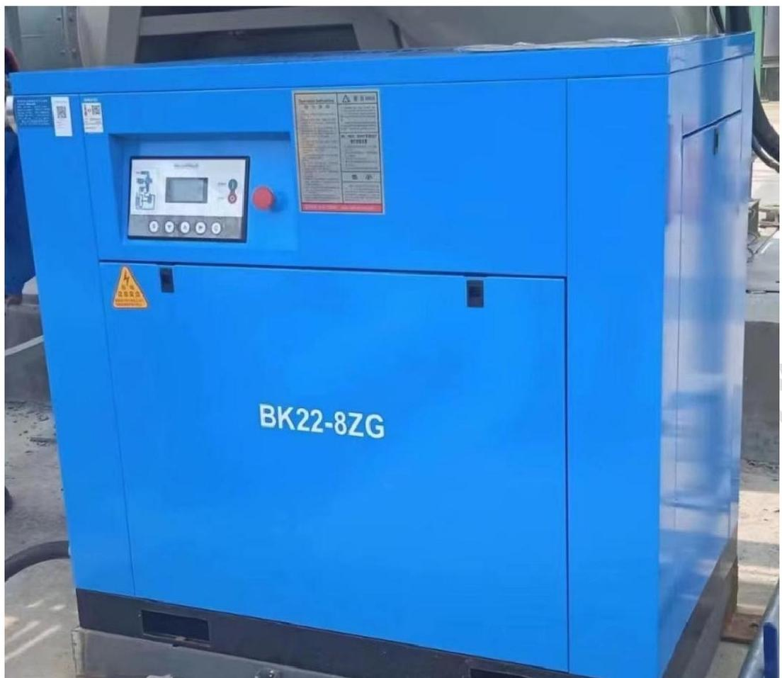

BK22-8ZG Air-cooled Screw Machine Technical Parameters

Screw Group | 5:6 helical rotor
Compression Mode | Continuous, single-stage
Compressed Air Outlet Pressure | P₂=0.8MPa
Cooling Mode | Air-cooled
Compressed Air Outlet Temperature | About 10℃~15℃ higher than ambient temperature
Lubricating Oil Quantity | Approximately 8.6 liters
Motor Speed | N=2930r/min
Rated Power | 22kW
Displacement | V=3.45m³/min
Working Weight | Approximately 390kg
Maximum Air Temperature | 45℃
Minimum Air Temperature | 0℃
Oil Consumption | Discharge oil content less than 3PPM
Noise | 74dB(A)

·High Energy Efficiency
·Continuous Improvement

· Mutual Benefit
·Trustworthy Cooperation

13

External dimensions (length × wide × Height (mm) | 1200×800×1120

·High Energy Efficiency
·Continuous Improvement

· Mutual Benefit
·Trustworthy Cooperation

14

